Lesson 4 Lesson-End Project
Create a new branch and merge the branch in Git

Project Agenda: To create a new branch and merge it in Git

Description: You are working in a IT company. Your company is working on a project which contains three modules and you have been asked to work on one of the module. Your company asked you to upload all the project files in the GitHub repository. You can create a new branch and work on it so that you don't impact the main code base. After you complete your module you can merge it into the master branch.

Tools required: Git

Pre-requisites: You must have installed Git in the lab in order to proceed. In case you do not have it please refer to Lesson 4 Demo 1 to install and setup Git.

Expected Deliverables: Create a GitHub repository, clone the GitHub repository, create a new branch, switch between the branches, and merge the branch

Steps to be followed:
- Create a new repository
- Clone the GitHub repository
- Create a new branch and verify the creation of the new branch
- Rename an existing branch and list all the branches in your repository
- Create a new branch and switch to the new branch
- Create a file and commit the changes
- Check the status of the new branch
- Delete the branch and verify the deletion of the branch
- Switch back to the main branch
- Merge the branches
Step 1: Creating a new repository
1.1 Open the browser in your lab, go to github.com, and log in to your account
1.2 Click on the + icon from the upper-right corner of the page and select New repository from the drop-down menu
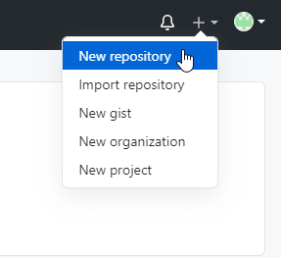
1.3 Enter lesson-end project the Repository name. Entering Description is optional.
1.4 Choose Public for the repository type
1.5 Select Initialize this repository with a README to include a README file for the repository
1.6 Click on the Create Repository button

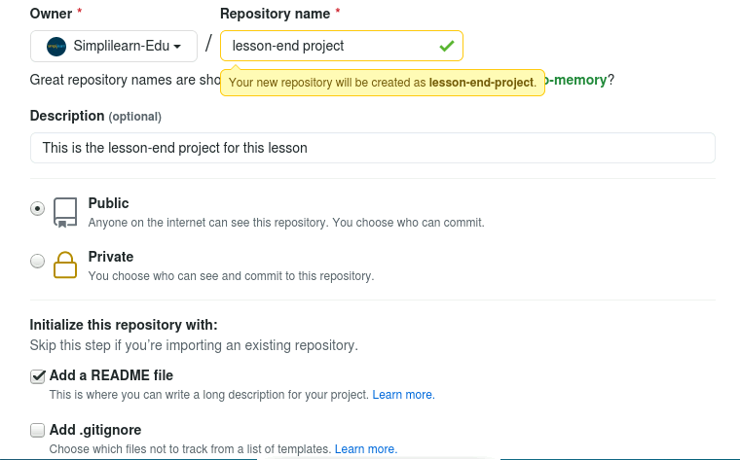

Step 2: Clone the GitHub repository
2.1 Open the browser in your lab, Go to github.com, and log in to your account
2.2 Open the lesson-end-project repo and click on the Code button
2.3 Click on the icon as shown in the following image to copy the URL provided under HTTPS
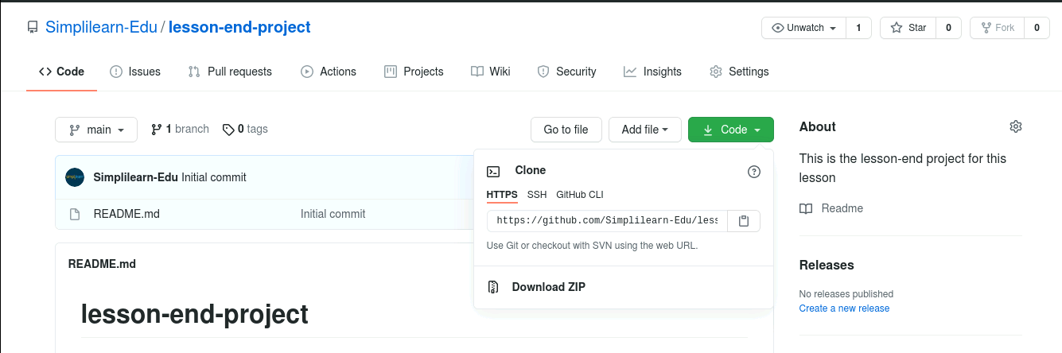

2.4 Open the Terminal tab on your lab and use the following command to clone the repository:
$ git clone URL
Note: Replace URL with the copied URL from the repository
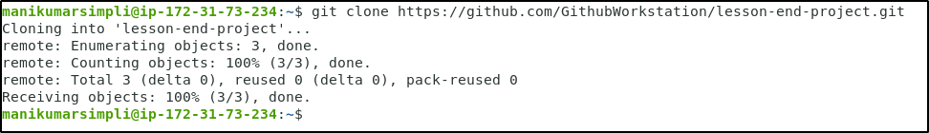

Step 3: Create a new branch and verify the creation of the new branch
3.1 Navigate to the lesson-end-project
cd lesson-end-project
3.2 Use the following command to create a new branch in your repository:
git branch project_branch

3.3 Verify the creation of the new branch
git branch
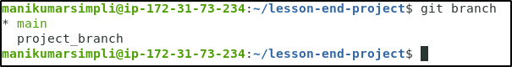

Step 4: Rename an existing branch and list all the branches in your repository
4.1 Use the following command to rename the new_branch:
git branch -m project_branch1
4.2 Use the following command to list the branches to verify the new name of the branch:
git branch
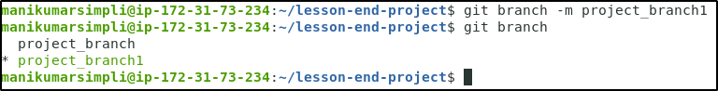

Step 5: Create a new branch and switch to the new branch
5.1 Execute the following command to create a new branch:
git branch project_branch2
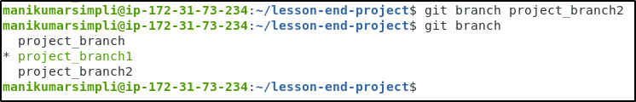
5.2 Use the following command to switch to the newly created project_branch2:
git checkout project_branch2
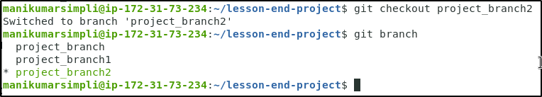

Step 6: Create a file and commit the changes
6.1 Use the following command to create a file:
vi index.html
6.2 Add the following code in the index.html file
<html>
<body>
<p> This is a lesson end project. </p>
</body>
</html>
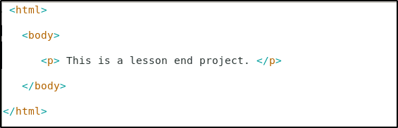
Note: Press Esc button and enter :wq to save the file.

6.3 Use the following commands to add the file to the project_branch2 and commit the changes:
git add index.html
git commit -a -m "file modified"
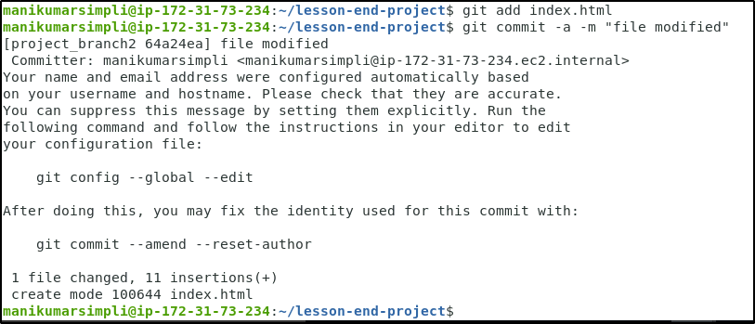

Step 7: Check the status of the new branch
7.1 Check the status of the new branch using the following command:
git status
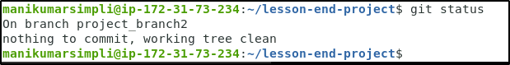

Step 8: Delete the branch and verify the deletion of the branch
8.1 Use the following command to delete the newly created branch:
git branch -d project_branch

8.2 Verify the deletion of the branch
git branch
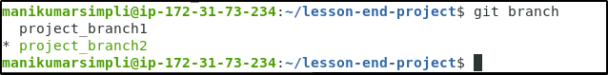

Step 9: Switch back to the main branch
9.1 Use the following command to switch back to the main branch:
git checkout project_branch1

Step 10: Merge the branches
10.1 Use the following command to merge the test_branch to the main branch:
git merge project_branch2
